

CP2406 Programming 3 Assignment 2

Nguyen Hoang Anh

[Company Name]

# **User Stories**

User Story 1

As a user, I want to the simulator can predict the time my car moves from my house to my office.

User Story 2

I am a student and I go to school every day. My dad sometimes takes me to school by car, sometimes I go to school by bus, sometimes my friend picks me up by his motorbike.

User Story 3

As a user, I want to keep my developed city to use again later so that I make sure not to disappear all of changes for my customized city.

User Story 4

As a user, update vehicle rate when I run simulation so that I can control how many vehicles should place on the road.

User Story 5

As a user, I want the stop button to stop the simulator while moving vehicles on the road so that I can terminate running process of simulation

## **Developer User Stories**

Developer User story 1

The simulator will allow users to set the speed of their car, roads on the map and the length of these roads. Then it will display the time of simulation as well the process of simulation when the car moves on the map. Priority is High and Estimate time is 3 days. For the testing, abstract the vehicles class and call some methods to move the cars.

Developer User Story 2

There are bus and motorbike for this car simulator. Priority is low and Estimate time is 1 day. For the testing, abstract the vehicles class and call some methods to move the cars.

Developer User story 3

The simulator makes the program to save all of the data that cannot occur data missing to customers. Priority is High and Estimate time is 3 days. For the testing, save the all data as a file at main method and load the data to view the map again.

Developer User story 4

User can set the cars on roads and get information about them. Priority is Medium and Estimate time is 2 day. For the testing, the main method will get all the car on roads, on map and display their status

Developer User story 5

A Stop button will be created to stop the simulator. Priority is Medium and Estimate time is 2 day. For the testing, run the simulator and press stop button

# **UML Diagram**

# **GitHub**

<https://github.com/HoangAnhNguyen269/NguyenHoangAnh_CP2406_Assignment2>

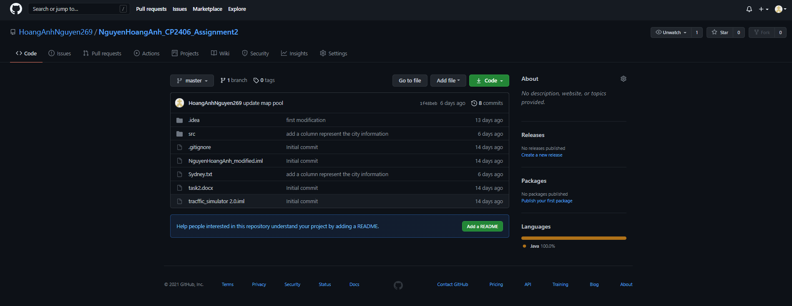

# **Screenshot**

